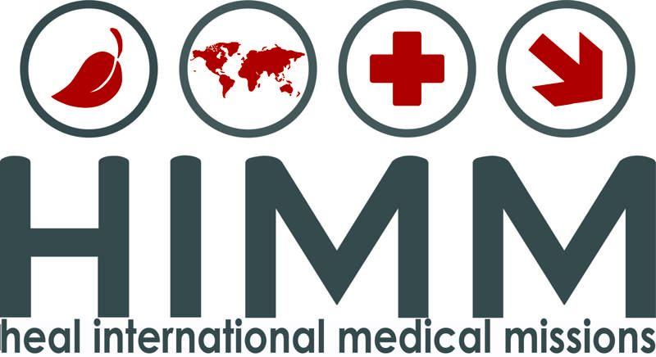

October 2017
Dear HIMM supporter,

As you all know by now, on September 20, hurricane Maria left the US territory of Puerto Rico devastated. HIMM, founded by Dr. Juan Padilla a local Puerto Rican neurosurgeon, is planning on addressing the humanitarian need there.

Between October 26 and November 29, HIMM is planning on sending five medical teams of 10-15 to the town of Yauco on the southern side of the island. These teams are responding to the currently expressed needs of the local medical community. They relate that emergency and medical personnel are needed more than surgical.

As HIMM does not generally operate as a relief organization and does not keep funds for such a project in reserve, we are asking you to consider a generous donation to fund the $75,000 needed for the transportation and logistical cost of these teams.

You can easily make this donation by going to our website himmonline.org and click on “donations” then “financially” and click the Paypal box. Add a note to explain this is for Puerto Rico within the Paypal dropdown. Or send a personal check to HIMM with a note and mail to: 4209 N. Conway Ave; Ste B1-1; Palmhurst, TX 78573

Finally, please feel free to contact myself or Lupita Silva our coordinator any time for information or questions, especially if you are willing to serve on one of these teams. My phone number is 956-458-7434. Lupita's is 956- 648-1186.

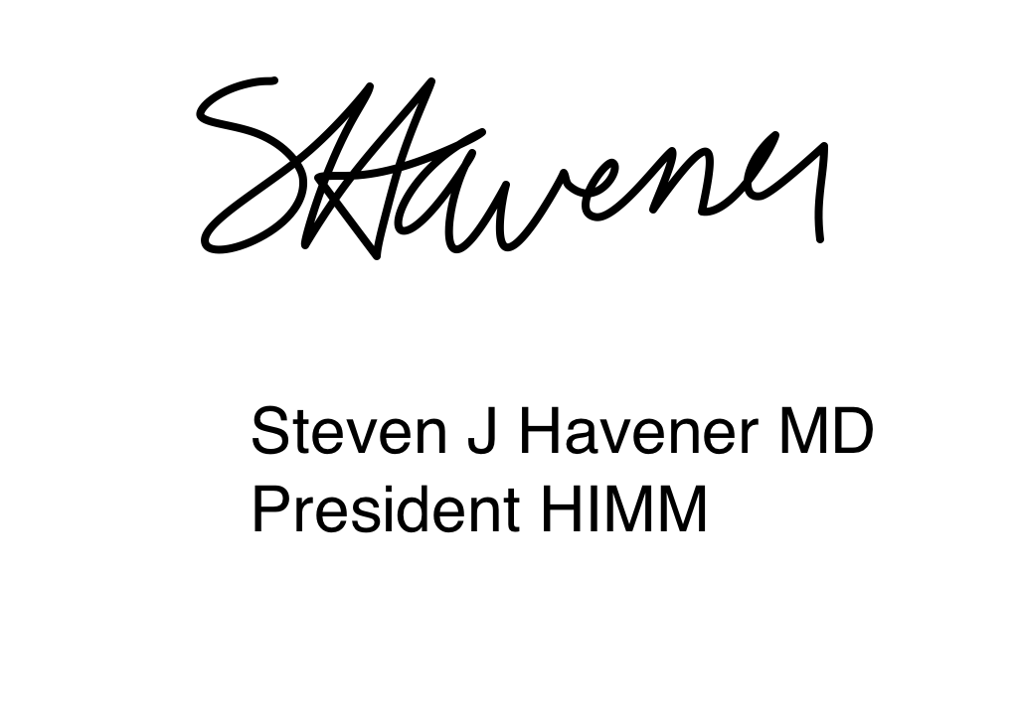
Sincerely,

